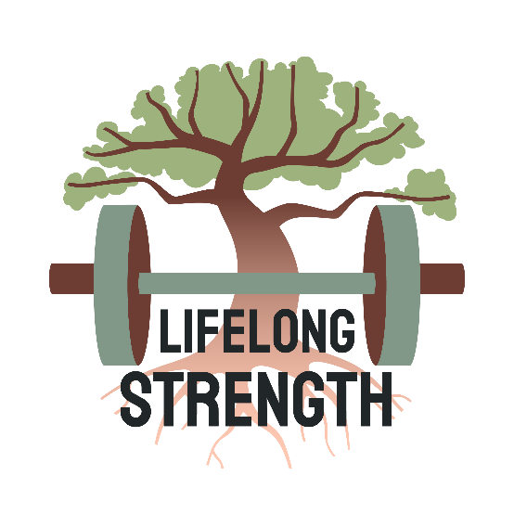
Strength for Lifelong Health
A 6 week evidence informed online coach development programme
“Helping coaches confidently apply strength training to improve long-term health outcomes in everyday populations.”
Strength training is one of the most powerful tools we have for improving long-term health, but many coaches and PTs are still left trying to bridge the gap between general fitness qualifications and confidently applying strength principles with real-world clients.
Applied Strength for Health is a small-group online CPD programme designed to help coaches develop a more practical, evidence-informed approach to strength training for health.
This is not a generic content library or passive online course.
It’s a guided coach development experience focused on:
- applying strength principles with confidence,
- improving client outcomes,
- and developing practical coaching decision-making.

Over 6 weeks, we’ll cover:
- The role of strength training in long-term health
- Coaching and programming foundations
- Regression and progression strategies
- Load management and recovery
- Coaching communication and adherence
- Applying strength principles with everyday clients

Included:
- Weekly recorded teaching sessions
- Practical coaching tasks and case studies
- Private coach community
- Weekly live online office hours/Q&A (recorded)
- Final applied coaching assessment
- Certificate of completion
Assessment:
- You will be provided with a case study example and will be asked to provide the answers to a series of questions to demonstrate your applied knowledge.

Designed for:
- Personal trainers
- Online coaches
- Gym instructors
- Rehab and health professionals
- Coaches wanting to build confidence in strength-based coaching

Format:
- Fully online
- Small-group learning environment
- Approx. 2–3 hours per week
- Limited cohort size

Investment:
- £200 per person for the founding cohort
Dates:
- Due to start Monday 3rd August, 2026
Whether you’re looking to strengthen your coaching foundations, improve client outcomes, or prepare for further development in strength & conditioning, this programme is designed to give you practical tools you can apply immediately.

